Searching 2D Lists

Look at this code:
clubs = [["art", 12], ["chess", 18], ["code", 15]]
target = input("Club to find: ")
target = target.lower()
found = False
for club in clubs:
if club[0] == target:
print("Members:", club[1])
found = True
if found == False:
print("Club not found.")

What do you think this code will display?
Click or tap here to enter text.

Run the code. Compare the result with your prediction:
Click or tap here to enter text.

Let’s investigate! Answer the questions below:
- Why is the target normalised before it is compared with stored record names?
Click or tap here to enter text.

- Why must found start as False before the search loop?
Click or tap here to enter text.

- What goes wrong if the not-found message is placed inside the loop?
Click or tap here to enter text.

- If you enter code, what message appears, and does Club not found. appear?
Click or tap here to enter text.

Searching 2D Lists

Look at this code:
clubs = [["art", 12], ["chess", 18], ["code", 15]]
target = input("Club to find: ")
target = target.lower()
found = False
for club in clubs:
if club[0] == target:
print("Members:", club[1])
found = True
if found == False:
print("Club not found.")

Use the code above to help you. After completing each challenge below, run your program to test that it works correctly. Save each completed challenge program in a new file.

Programming Challenges

Challenge 1
Change the search so the user enters a member count instead of a club name. Display the matching club. Test 15; the program should display "Club: code".
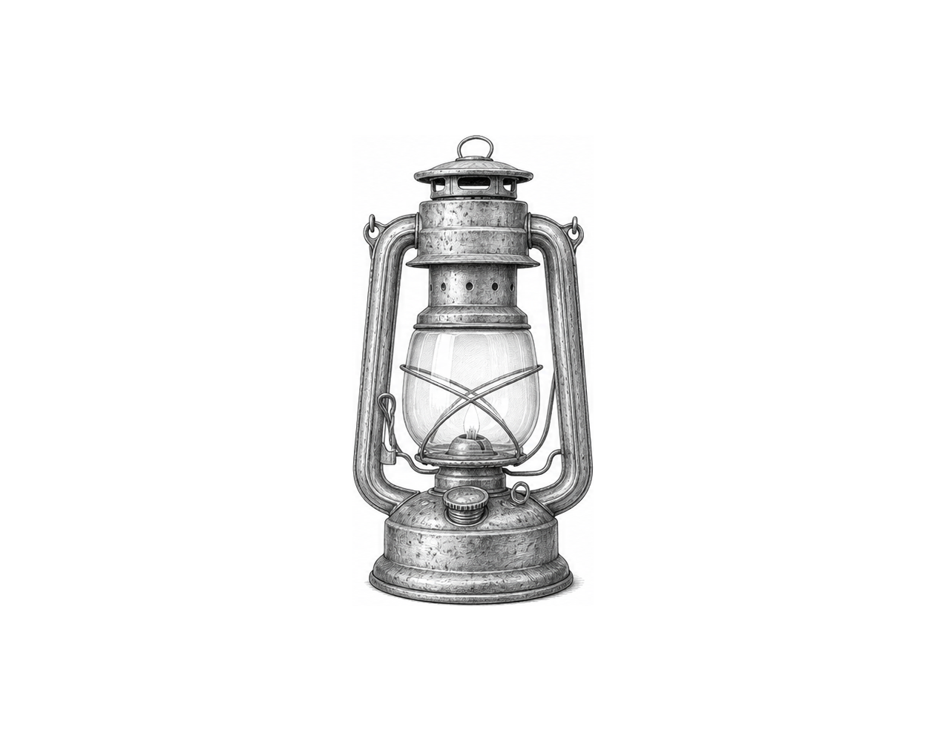

Challenge 2
When [club][0] matches [target], ask for a new member count and store it in [new_members]. Update [club][1], then display "Updated:" followed by the changed row. Test "Chess" and 20; display "Updated: ['chess', 20]". Test "Music"; display "Club not found."

Challenge 3
Store ["orbit", 120], ["harbour", 96] and ["forest", 144] in [books]. Ask for a title and store its lower-case value in [target]. Use a for loop to compare [target] with each title. Display "Pages:" followed by the page count when a title matches. Display "Book not found." only after every row has been checked and no match was found. Test "Harbour"; display "Pages: 96". Test "Music"; display "Book not found."

Searching 2D Lists

Fix the code!

This code has errors! Look closely at the code to find the problems:

clubs = [["art", 12], ["chess", 18]]
target = "chess"
found = False
for club in clubs:
if club == target:
found == True
if found == False:
print("Club not found.")

Rewrite the whole program in the box below with fixes to the errors.
Click or tap here to enter text.

After you are confident that you fixed all the errors, copy the code from the box and run it.

Did it work correctly on your first try? Did you find all the errors?
Click or tap here to enter text.

